Sponsorship Packages

Corporate Sponsor: $1,000
- Special Recognition on Program Banner as Corporate Sponsor
- Half-page Ad in Program
- Advance Registration for Tournament [One Team at No Charge]
Major Sponsor: $600
- Half-page Ad in Program
- Recognition in Program as Major Sponsor
- Advance Registration for Tournament [One Team at Half Price – $160]
Sponsor: $300
- Quarter-page Ad in Program
- Recognition in Program as Sponsor
- Advance Registration for Tournament [One Team at only $240; one golfer free]
Hole Sponsor: $100
- Hole Sign at Tee or Green
- Recognition in Program as Hole Sponsor
- Advance Registration for Tournament [One Team – full price]
Hole Sponsor w/Color Logo: $125
- Hole Sign w/Color Logo at Tee or Green
- Recognition in Program as Hole Sponsor
- Advance Registration for Tournament [One Team – full price]

Big Board Donor: $100⁺ Value
- Recognition on Big Board
- Recognition in Program as Big Board Donor
- Advance Registration for Tournament [One Team – full price]
Donor: $25 - $99 Value
- Recognition in Program as Donor

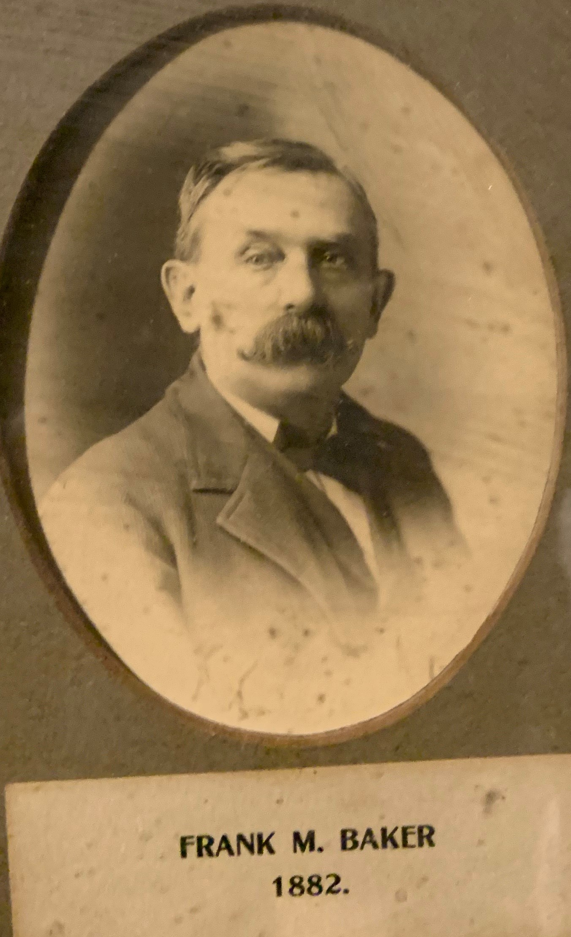

Owego Hose Teams, Inc., a charitable 501c3 not for profit, is hosting an inaugural Central NY Firefighters Association (CNYFA) Golf Tournament in honor of Frank Baker on Saturday, October 5, 2024 at the Tioga Golf Club in Nichols, NY. We hope that you will be able to play and/or sponsor the tournament.

All monies raised from the tournament will support CNYFA, an organization founded by Mr. Baker (Owego’s Own) in 1893.

Your support is greatly appreciated.

Sincerely,

Pat Gavin
Tournament Chair

Register online at:
www.OwegoHoseTeams.com

Entry Form

COST - $340 per team
(Only $85 per person to golf)
Make checks payable to:
Owego Hose Teams, Inc.

Entry fee includes greens fees & carts, buffet with beer, soda, and hot dogs on course with beverages and lots of prizes.
Sponsorship Packages

[ ] Corporate Sponsor: $1,000

[ ] Major Sponsor: $600

[ ] Sponsor: $300

[ ] Color Hole Sponsor: $125

[ ] Hole Sponsor: $100

[ ] Big Board Donor: $100⁺ Value

[ ] Donor: $25 - $99 Value

Registration Form
11 AM Shotgun Start
Team Captain:
Telephone:
Email:
Shirt Size:
Player 1:
Telephone:
Email:
Shirt Size:
Player 2:
Telephone:
Email:
Shirt Size:
Player 3:
Telephone:
Email:
Shirt Size:
Guest Buffets ($25)____________________

HUGE
RAFFLE
50/50

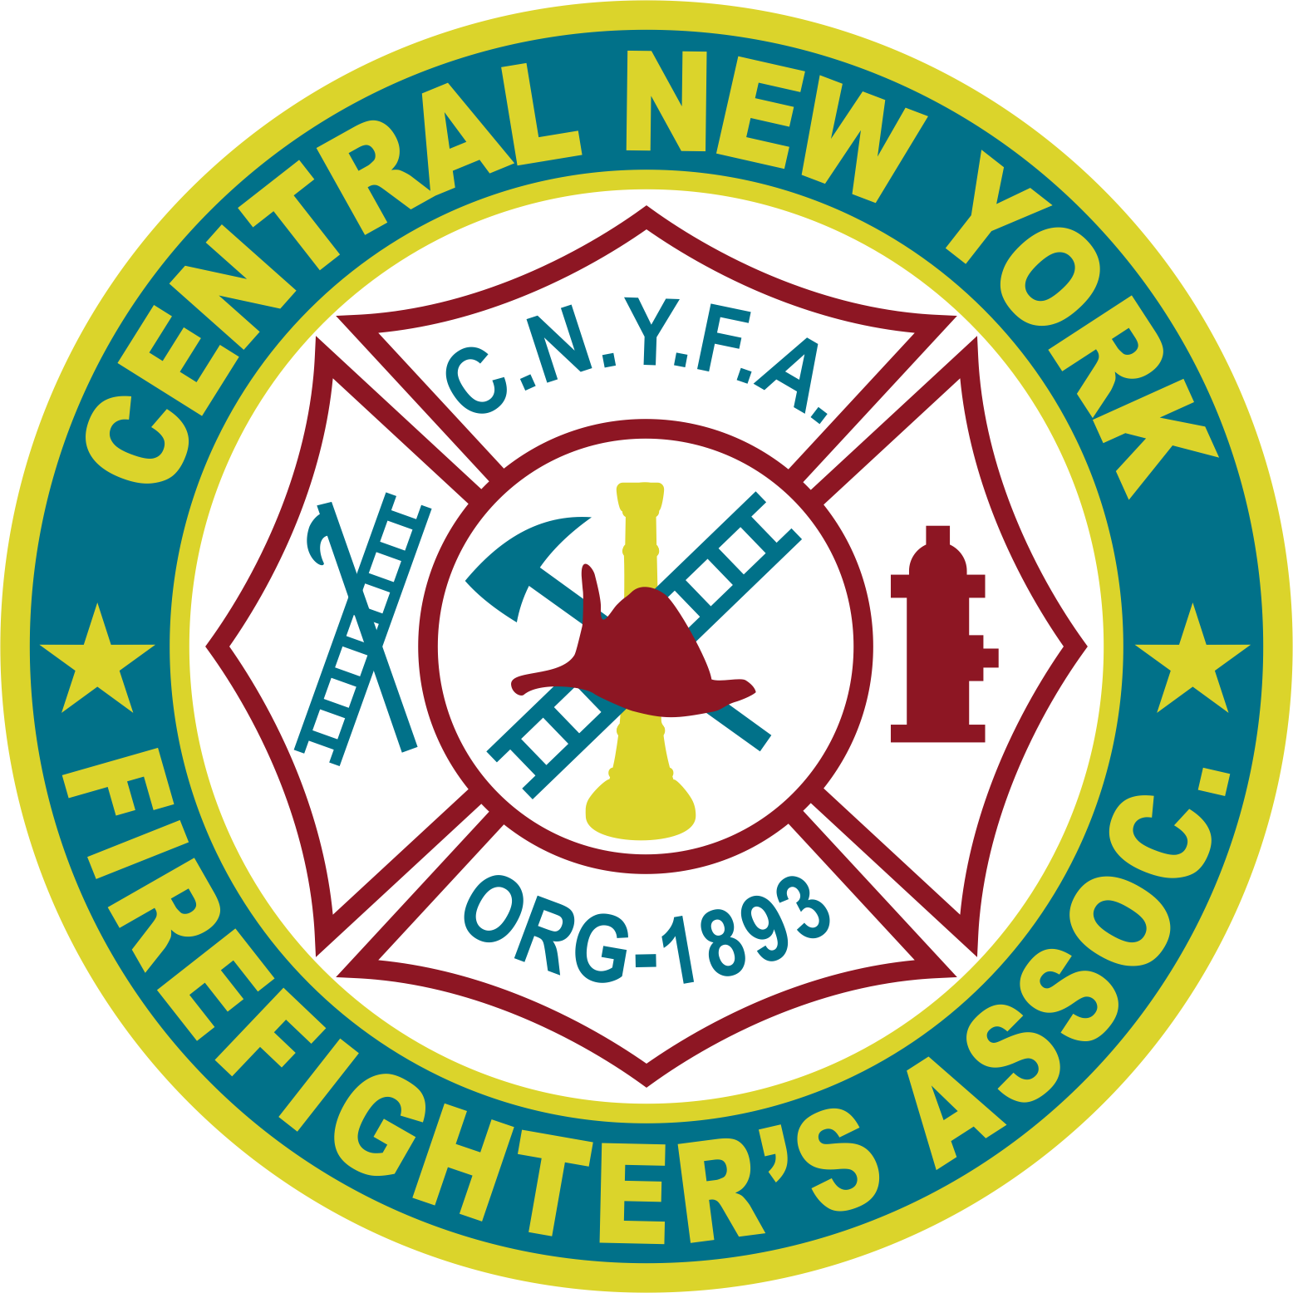

To Benefit:

Central New Firefighter’s Association
Saturday, October 5th

^{Tioga Golf Club}

^{RAIN OR SHINE}
CAPTAIN and CREW FORMAT

10:00 am: Registration Opens
(Morning Round)

11:00 am: Shotgun Start
Buffet at end of Round
_________________

4:30 pm: Buffet, Prizes,
and Drawings for the
50/50 Raffle & Big Board

(Guest buffet tickets must be purchased in advance $25)

www.OwegoHoseTeams.com

Inaugural CNYFA Presidents Cup
Saturday,
October 5, 2024

Tioga Golf Club
Nichols, NY

Registration Information
(Registration Deadline September 1st)
Open to Men, Women and Youth Total Number of Teams – 32

Advance registration available for sponsors and donors.

Initial sign-ups can be mailed to Pat Gavin
461 East Main Street, Owego, NY 13827
firemangavin@gmail.com
$340 per team payable at sign-up
Make checks payable to:
Owego Hose Teams, Inc.

Each Team Captain
is responsible for his/her team,
including finding a substitute
if a team member cannot play.
Refunds cannot be provided.

FOR INFORMATION

Pat Gavin (202) 494-9108

firemangavin@gmail.com

